
Stability Capitalism
A Framework for AI Transition Economics
REnee K. McInerney
MacAisling Corp.
version 2.0 December 2025
CoNDENSED Policy Brief
Table of Contents
0.0 Executive Summary 3
1.0 The Problem: Velocity Mismatch 4
1.2 Structural Constraints on Retraining 4
1.3 Capital Reallocation, Not Cost Elimination 4
2.0 The Collection Mechanism: Pricing Automation at the Source 6
2.1 Why Inference Is the Correct Unit 6
2.2 Fee Structure 6
2.3 Why Not Corporate Taxes? 6
3.0 Revenue Robustness & Scaling 6
4.0 The AI Dividend: Benefit Structure 7
4.1 Floor, Not Ceiling 7
4.2 Individual-Based Design 7
4.3 Social Security Integration 7
5.0 Inflation & Housing: The Real Risk, Directly Addressed 7
6.0 Administrative Simplicity & Enforcement 7
7.0 Macro Outcomes 8
8.0 Objections, Answered Briefly 8
9.0 Conclusion 8
Selected References for "Stability Capitalism" Brief 9

0.0 Executive Summary
Artificial intelligence is driving productivity gains at a pace unmatched in modern economic history. Across healthcare, finance, logistics, retail, government, and technology, firms are consolidating or eliminating skilled roles previously considered durable. Displacement is occurring faster than labor markets, retraining systems, and social insurance mechanisms can absorb.
This paper proposes Stability Capitalism: a market-aligned framework that converts a small portion of AI-generated productivity into a permanent economic stability layer for households. The mechanism is funded by a microscopic, usage-based fee on commercial AI inference, collected at cloud API endpoints where AI activity is already metered and billed.
The proceeds fund an AI Dividend—a monthly income floor that protects individuals during prolonged labor disruption without suppressing work incentives, raising taxes on workers, or slowing innovation.
Core Design
- A per-inference fee starting at $0.0009, declining toward $0.00054 as scale matures
- Collected automatically from commercial AI providers serving U.S. users
- Funds a phased monthly dividend that reaches a $3,000 psychological-safety floor by Year 4

Key Properties
- No new income or payroll taxes
- No cuts to Social Security or disability benefits
- Automatic scaling with AI adoption
- Counter-cyclical by design
- Administratively simple and auditable

Stability Capitalism is not a replacement for capitalism; it is a stability layer that prevents systemic collapse during rapid technological transition.
This brief summarizes a longer technical working paper available upon request.

1.0 The Problem: Velocity Mismatch
1.1 Persistent Displacement, Not Cyclical Unemployment
Recent labor market data shows that layoffs are concentrated among mid-career, skilled workers, particularly those aged 45+. These workers face longer reemployment gaps, larger wage losses, and fewer viable retraining paths.
Unlike prior automation waves, AI replaces cognitive and coordination tasks across sectors simultaneously. This breaks the historical assumption that displaced workers can retrain into adjacent roles within a reasonable time horizon.
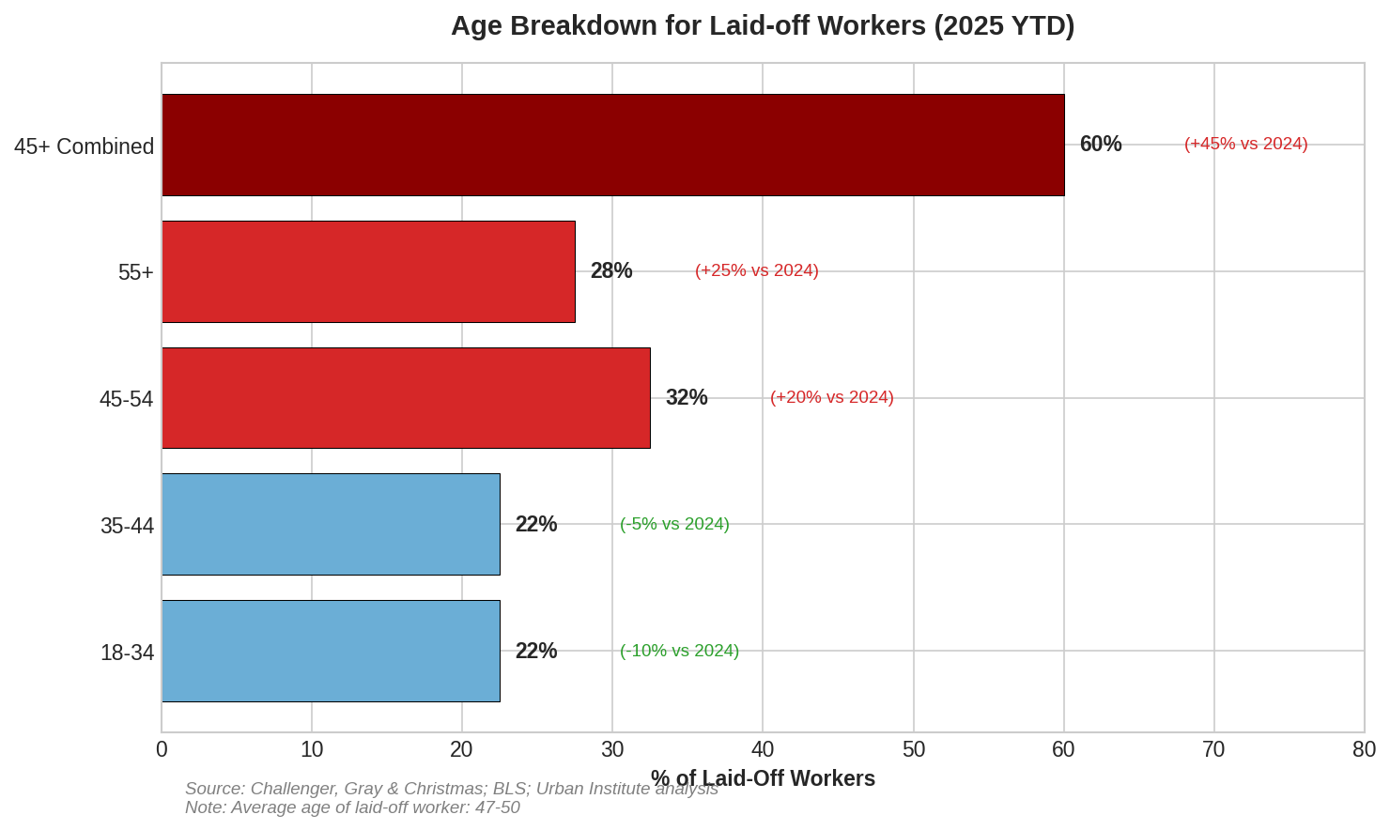
Figure 1 Age Breakdown for Laid-off Workers (2025 YTD)

1.2 Structural Constraints on Retraining
Retraining programs operate on multi-year timelines. Mortgages, healthcare costs, and family obligations do not. For many mid-career workers, the retraining path itself becomes a source of instability rather than a solution.
Figure 2 The Asymmetry: Who Loses vs. Who Gains

1.3 Capital Reallocation, Not Cost Elimination
When firms replace labor with AI, costs do not disappear. They migrate:
- From wages → recurring inference and compute fees
- From households → high-margin cloud and model providers

This shift concentrates gains while dispersing losses—creating a systemic imbalance that legacy policy tools were not designed to manage.
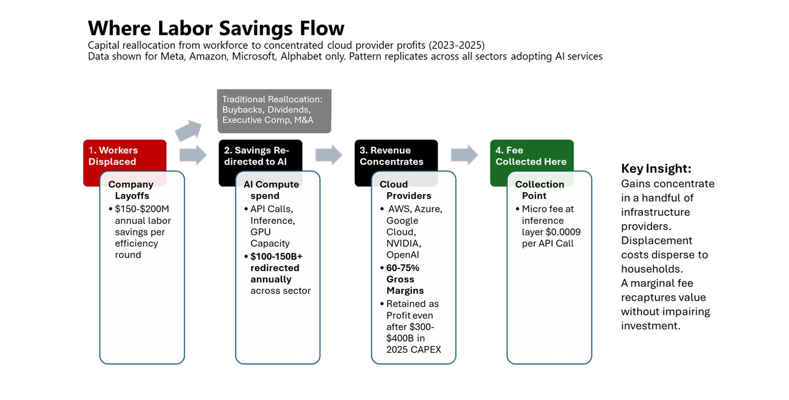
Figure 2 Where labor Savings Flow - capital reallocation from workforce to concentrated cloud provider profits (2023-2025)
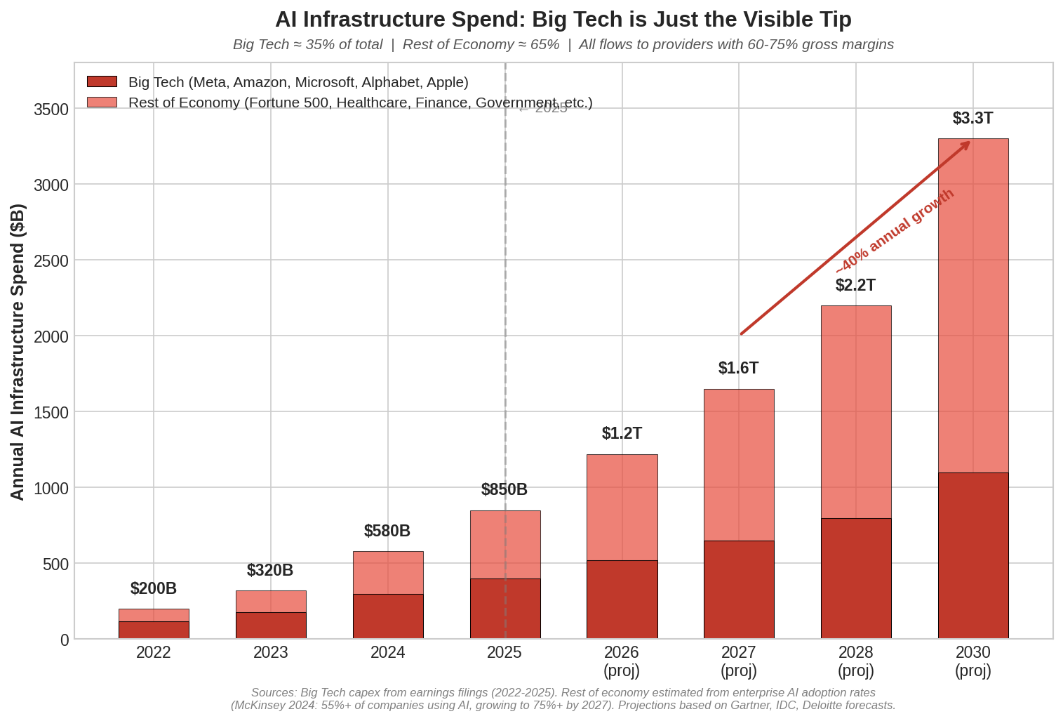
Figure 3 AI Infrastructure Spend - Big Tech is Just the Visible Tip (Economy-wide Spend 2022-2030)

2.0 The Collection Mechanism: Pricing Automation at the Source

2.1 Why Inference Is the Correct Unit
Commercial AI inference is:
- Metered
- Auditable
- Already billed
- Directly tied to labor-replacing activity
This makes it uniquely suited for a precision contribution mechanism, unlike profit or revenue taxes that lag behavior and invite evasion.

2.2 Fee Structure
- Initial rate: $0.0009 per commercial inference
- Long-run rate: $0.00054 per inference
- Economic impact: < 0.15% of operating income for major providers
At typical enterprise usage, the fee adds less than $1 per $1,000 of AI compute spend.
Any firm claiming that this fee necessitates price increases would be signaling market power, not cost pressure—implicating existing antitrust scrutiny rather than economic necessity.

2.3 Why Not Corporate Taxes?
Traditional corporate taxes punish profits after the fact and discourage investment broadly. Stability Capitalism prices automation at the moment it replaces labor, preserving innovation incentives while preventing systemic collapse.
This is precision economics, not redistribution.

3.0 Revenue Robustness & Scaling
Stability Capitalism does not rely on a single forecast of AI usage. The fee is usage-based and automatically scales with actual inference volume.
Across conservative, mid-range, and high-growth scenarios:
- Early years fund partial distributions and build reserves
- Later years support full dividend coverage and fee reductions
Because the mechanism scales with realized activity, precise prediction of daily inference volume is not required for fiscal viability.

4.0 The AI Dividend: Benefit Structure
The AI Dividend launches at $2,000/month for individuals earning under $50,000, and scales to the full $3,000/month psychological-safety threshold by Year 4 as coverage expands and inference volume matures.
Unless otherwise noted, the following subsections describe the fully mature benefit structure

4.1 Floor, Not Ceiling
At maturity, the AI Dividend establishes a $3,000 monthly income floor:
- Below median full-time earnings
- High enough to eliminate fear-driven collapse
- Preserving strong incentives to work and advance

4.2 Individual-Based Design
- Eligibility and payment are individual, not household-based.
- Protects autonomy and escape from abusive situations
- Gradual phase-out between $80k–$120k individual income
- No benefit cliffs

4.3 Social Security Integration
- No cuts. Ever.
- Seniors below $3,000 receive a top-up only
- Earned benefits remain intact

5.0 Inflation & Housing: The Real Risk, Directly Addressed
Unconditional income can create pressure only in housing-constrained markets. Stability Capitalism explicitly neutralizes this risk through:
- Land Value Tax (captures rent-seeking)
- YIMBY zoning reform (expands supply)
- Rent spike caps during transition
- AI-accelerated construction
This prevents landlord capture and keeps the AI Dividend flowing to households—not assets

6.0 Administrative Simplicity & Enforcement
- Collected through existing cloud billing systems
- Distributed via IRS/Treasury rails
- No applications, no caseworkers, no new bureaucracy
Compliance is unavoidable: major providers cannot exit the U.S. market, and enforcement mirrors existing digital services tax frameworks.

7.0 Macro Outcomes
Stability Capitalism:
- Raises consumer demand (1.5–2.1% GDP lift)
- Improves health outcomes
- Reduces crime
- Stabilizes birth rates
- Strengthens Social Security solvency
- Regenerates local economies
These outcomes are consistent with evidence from Alaska, Kenya, Stockton, and other cash-transfer programs—scaled appropriately.

8.0 Objections, Answered Briefly
- “People will stop working” … Evidence shows they don’t
- “It’s inflationary” … Only housing; mitigated directly
- “It’s socialism” … Market-funded, no worker taxes
- “Corporations will flee” … They can’t
- “Why not just tax corporations?” … Precision vs blunt force

9.0 Conclusion
AI is not slowing. Labor disruption is not temporary. Stability Capitalism offers a durable, market-aligned response that converts machine productivity into human stability—without undermining innovation, incentives, or fiscal discipline.
Doing nothing is not neutral. It is the most expensive option.

Selected References for "Stability Capitalism" Brief
AI Displacement & Labor Risk
- McKinsey Global Institute. (2025). The state of AI in 2025: Agents, innovation, and transformation. McKinsey & Company. https://www.mckinsey.com/capabilities/mckinsey-digital/our-insights/the-state-of-ai-in-2025-agents-innovation-and-transformation
- World Economic Forum. (2025). The future of jobs report 2025. WEF. https://www.weforum.org/publications/the-future-of-jobs-report-2025
- Oxford Martin School. (2025). AI exposure predicts unemployment risk: A new approach to technology-driven job loss. Oxford Martin School Working Paper. https://academic.oup.com/pnasnexus/article/4/4/The_Future_of_Employment.pdf
- Bureau of Labor Statistics. (2025). Employment situation – September 2025 (USDL-25-1487). BLS. https://www.bls.gov/news.release/empsit.nr0.htm
Macroeconomic Risk & Cost of Inaction
- RAND Corporation. (2025). Macroeconomic implications of artificial intelligence (PE-A3888-3). RAND. https://www.rand.org/pubs/perspectives/PEA3888-3.html
- Congressional Budget Office. (2025). The budget and economic outlook: 2025 to 2035. CBO. https://www.cbo.gov/publication/60870
Income Floors, Work Incentives & Outcomes
- Alaska Permanent Fund Corporation. (2025). Annual report 2025. APFC. https://apfc.org/annual-reports
- Stockton Economic Empowerment Demonstration. (2025). Guaranteed income outcomes. SEED. https://www.stocktondemonstration.org/results
- GiveDirectly. (2025). 12-year basic income experiment: Kenya interim report. GiveDirectly. https://www.givedirectly.org/ubi-study
AI Scale, Compute & Cloud Economics
- McKinsey Global Institute. (2025). The economic potential of generative AI: The next productivity frontier. McKinsey. https://www.mckinsey.com/featured-insights/mckinsey-explainers/what-is-generative-ai
- Epoch AI. (2025). What Will AI Look Like in 2030?. Epoch AI. https://epochai.org/reports/ai-inference-volume-forecast
- Synergy Research Group. (2025). Cloud Market Share Trends – Big Three Together Hold 63% while Oracle and the Neoclouds Inch Higher. https://www.srgresearch.com/articles/cloud-market-share-trends-big-three-together-hold-63-while-oracle-and-the-neoclouds-inch-higher
Administrative Feasibility & Public Finance
- U.S. Government Accountability Office. (2025). Improper Payments: Information on Agencies' Fiscal Year 2024 Estimates (GAO-25-107753). https://www.gao.gov/products/gao-25-107753
- International Monetary Fund. (2025). Fiscal monitor: Spending Smarter: How Efficient and Well-Allocated Public Spending Can Boost Economic Growth – October 2025. IMF. https://www.imf.org/en/Publications/FM/Issues/2025/10/07/fiscal-monitor-october-2025
Housing & Inflation Constraints
- IMF. (2025). World Economic Outlook – AI and inequality. IMF. https://www.imf.org/en/Publications/WEO/Issues/2025/10/07/world-economic-outlook-october-2025

Extended modeling assumptions, welfare program analyses, and full source documentation are provided in the Stability Capitalism v2.0 working paper.

